**Question**:-Create your first ADF account where adf account name : mission100+yourname+yourdob and put it inside the resource group name azurelib.

Solution:-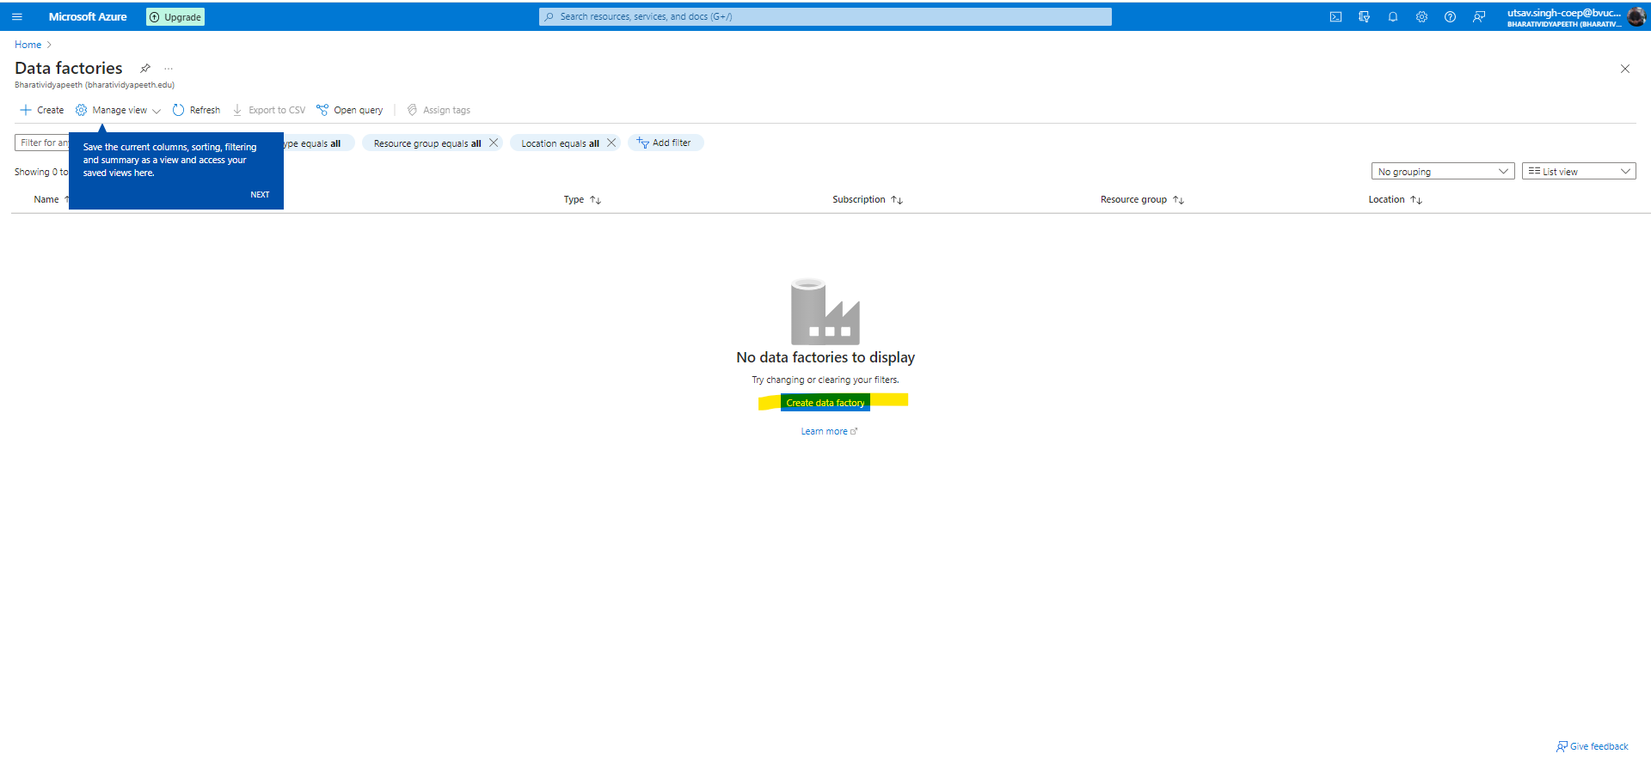

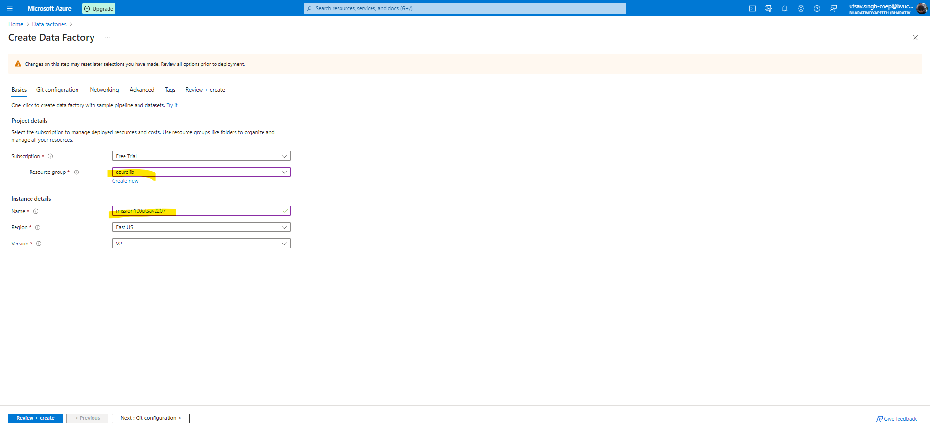

**And in Rest of steps keep as it is**

